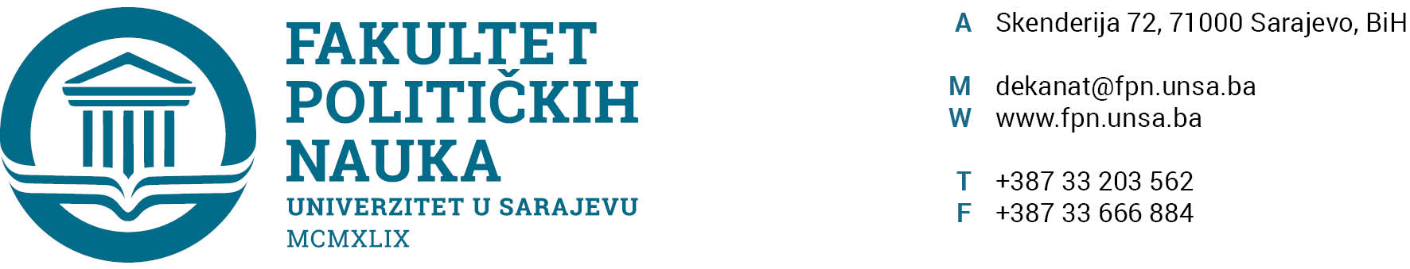

INVITATION LETTER
4th International Social Science Week
University of Sarajevo – Faculty of Political Sciences
May 12-16, 2025

University of Sarajevo – Faculty of Political Sciences since its establishment in 1961, has actively embraced various forms of international academic exchange. Over the past decade, we have dedicated significant efforts to fortifying international collaboration and expanding our network of partners. This endeavor involved initiating bilateral cooperation agreements with interested faculties and universities, developing an English-language course catalog for incoming students, and establishing comprehensive procedures for the preparation, implementation, and monitoring of realized mobilities. These efforts also encompass continuous information dissemination and promotional activities to encourage mobility. The Faculty of Political Sciences actively engages in numerous inter-institutional agreements and facilitates academic exchanges between students and staff with counterparts from faculties of political and social sciences from all over Europe.
In our pursuit of contributing to broader internationalization initiatives, we have launched an event called “International Social Science Week”. This year’s 4th International Social Science Week serves as an interdisciplinary forum, featuring lectures and discussions that highlight the faculty's international activities and collaborations. The genesis of this event stems from our desire to provide students with an expansive platform for knowledge acquisition and the exchange of perspectives with professors and colleagues from partner universities across Europe and the world.
The guest lectures conducted in English are strategically designed to inspire students to engage with major social issues through interdisciplinary collaborations transcending disciplines, languages, and borders. These lectures and discussions are of huge benefit for students across all three cycles of studies because we incorporate topics from various scientific disciplines taught at the Faculty of Political Sciences (political sciences, sociology, communicology, social work, security, and peace studies).
What’s happening at International Social Science Week this year?
This year’s International Social Science Week offers a diverse program that includes:
- Lectures from distinguished professors, designed for both students and guests
- Collaborative learning sessions for non-teaching staff to share insights with colleagues from our institution
- A scientific international roundtable in cooperation with the University of Oradea
- Cultural and networking activities to connect with colleagues
This year, the 4th International Social Science Week is scheduled to take place from May 12 to May 16, 2025. We extend a heartfelt invitation for your participation. Also, we emphasize that it would be an honor and privilege to have you either as a guest lecturer, non-teaching staff, and/or paper presenter at our international event.
If you are available and willing to participate, please confirm your attendance by filling out this GENERAL form: https://forms.office.com/e/Y4wHXdCjCM
The deadline for registration is February 28. 2025.

Additionally, on May 13, we are organizing a scientific sub-forum titled “Development and Challenges in the Western Balkans: Regional and European Models” in collaboration with our partners from the University of Oradea. Details about the call for papers and additional information are included in a separate document accompanying this invitation. A dedicated link for roundtable registration is also provided: https://forms.office.com/e/p7TpfMBmZa

Should you have any inquiries in the meantime, please feel free to contact us.
Sarajevo, January 21, 2024

Vice-Dean for International Cooperation

____________
Prof. dr. Sanela Šadić

