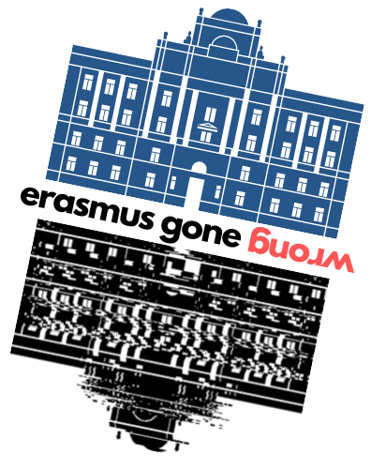
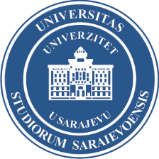

8th International Staff Training Week
University of Sarajevo
24-28 October 2022

Agenda – draft

Monday, 24 October 2022
- Registration
- Welcome ceremony
- UNSA and IRO presentation
- UNSA walking tour

Tuesday, 25 October 2022
- „Erasmus gone wrong“ presentations of partners about problems and challenges IRO is facing during implementation of Erasmus+ mobilities (both ways). We will share UNSA's and some of partners who are interested to present. Discussion is expected along with conclusions.

Wednesday, 26 October 2022
- 12th Scholarship Fair (IRO UNSA organizes international went inviting all local and internationl institutions to present their offer at the Fair that atracts 1000s of students and staff members. Participants of the staff week are automatically participating at the Scholarship fair) – all day event

Thursday, 27 October 2022
- Organized trip to Mostar and visit to the Džemal Bijedić University of Mostar with organized city walk tour - all day event

Friday, 28 October 2022
- Recap and feedback
- Final conculsions
- Certificates

