Dear colleagues,
Greetings from the University of Sarajevo, Faculty of Sport and Physical Education, Bosnia and Herzegovina. We are delighted to announce our:

1st INTERNATIONAL SPORT STAFF WEEK:

Date | 17 June – 21 June 2024
Short description | The International Sport Staff Week will serve as a platform to meet colleagues from various academic institutions to share good practices, learning and get inspired by each other, and build new partnership networks for future collaboration.  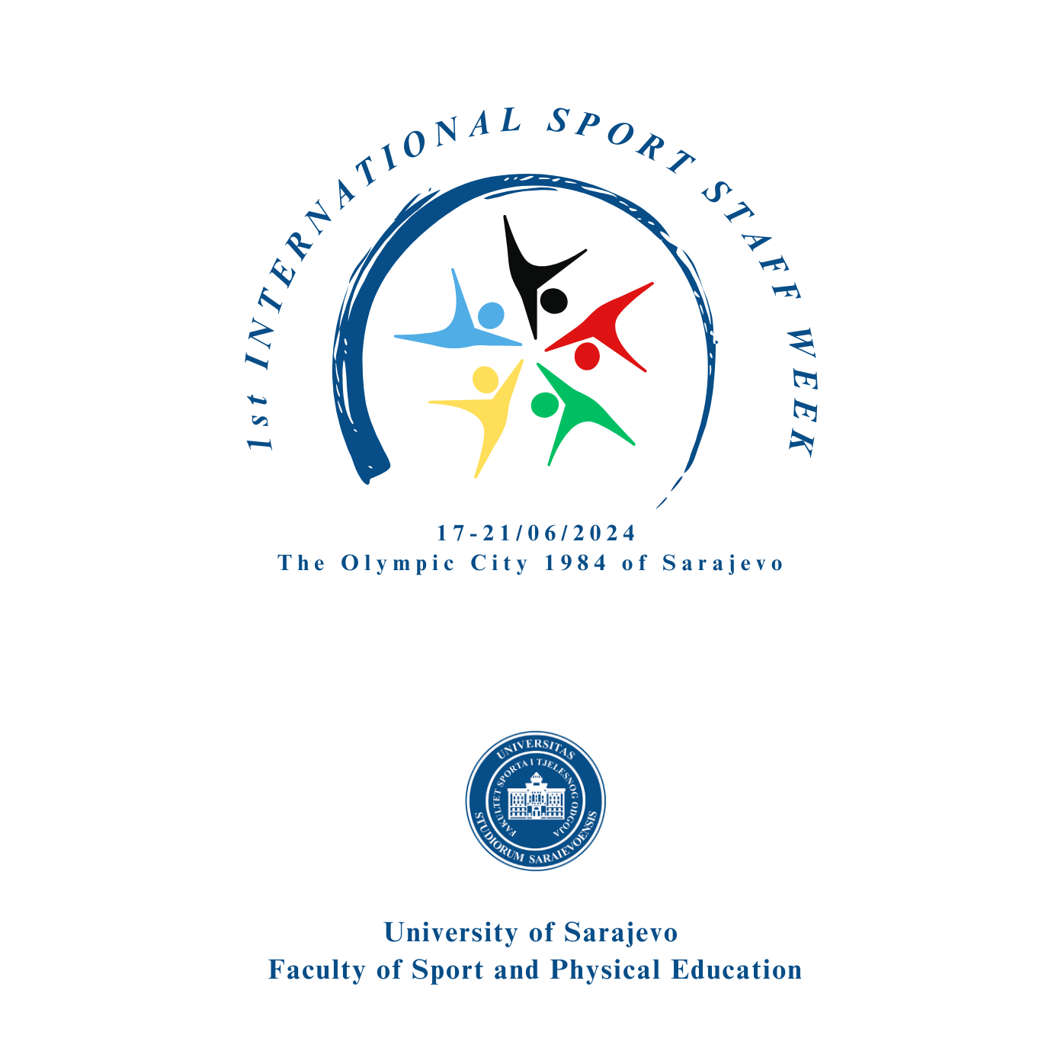  We will discuss what sports science and internationalisation mean beyond the traditional student and teaching mobilities and how we can make our universities truly internationalised higher education institutions. To gather partner universities who are interested in sharing their knowledge, expertise and experience through lectures, seminars, workshops and/or practical sessions.  Participation in the International Sport Staff Week is free of charge. However, all participants are expected to cover their travel, accommodation and living expenses from the Erasmus staff mobility for teaching/training grants or other funds.
Detailed programme | t.b.a. in February/March 2024
Target groups | Administrative staff and teaching staff from various departments.
Funding | We recommend you to apply for an Erasmus+ grant at your home institution.
Registration | https://docs.google.com/forms/d/1EoIvPoaTylv6D4vMy84vI8NkajMcWj8SKV9pPzDIFRU/edit?ts=659bc205
Registration deadline | 10 February 2024

In case of questions, please do not hesitate to contact us. We are already looking forward to welcoming you in Sarajevo, Bosnia and Herzegovina and wish you pleasant holidays.

